# Documentation – Report Page and PDF

# Introduction

The report page of the SecureBiz website will contain different statistics that will display how a user performed in their questionnaires and will output various vulnerabilities that were detected.

# Details for Report Page

Majority of the statistics are implemented, currently an overall design of the report page has been developed. This design varies depending upon whether the user choose to select a particular mitigation strategy for answering the question of select Gets started button to answer all the core questions.

1. **Report for any Mitigation strategy:**

Once the user is finished answering the question the user is presented with a Maturity level on the website for only the chosen mitigation strategy as shown below:

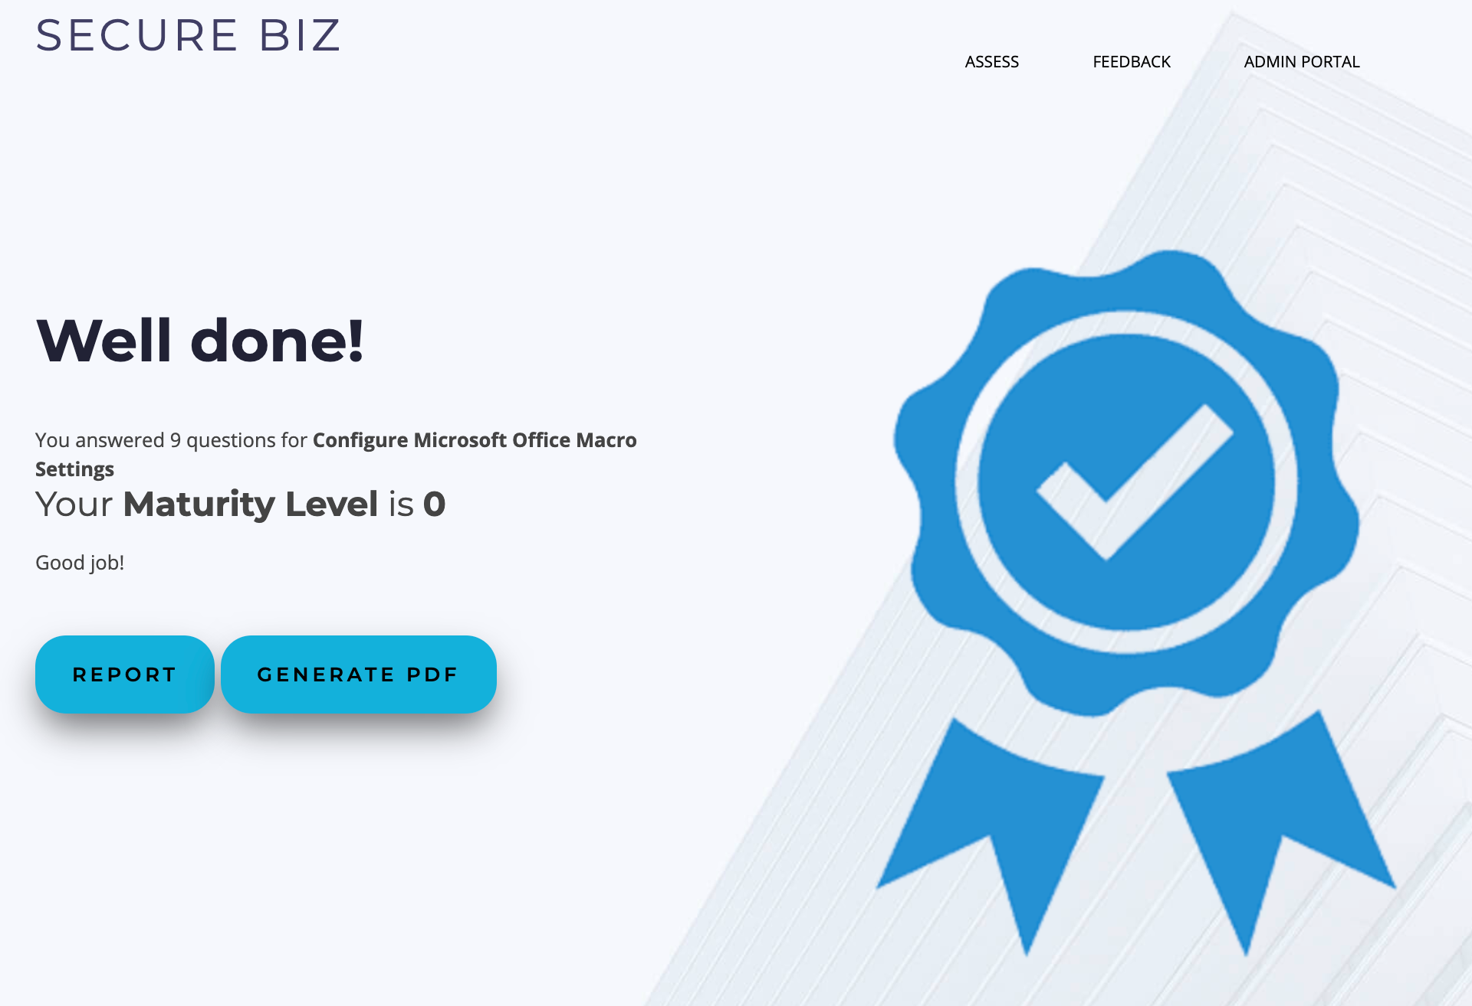

If the user clicks on the report button, he/she is presented with a report listing not only the maturity level but also the Recommendations as shown below:

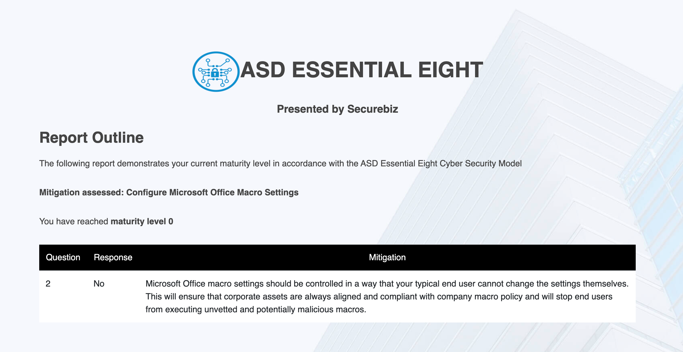

1. **Report after Answering Get Started core questions:**

The Html view of the report is listing a table with maturity level for all of the eight mitigation strategie as can be seen below:

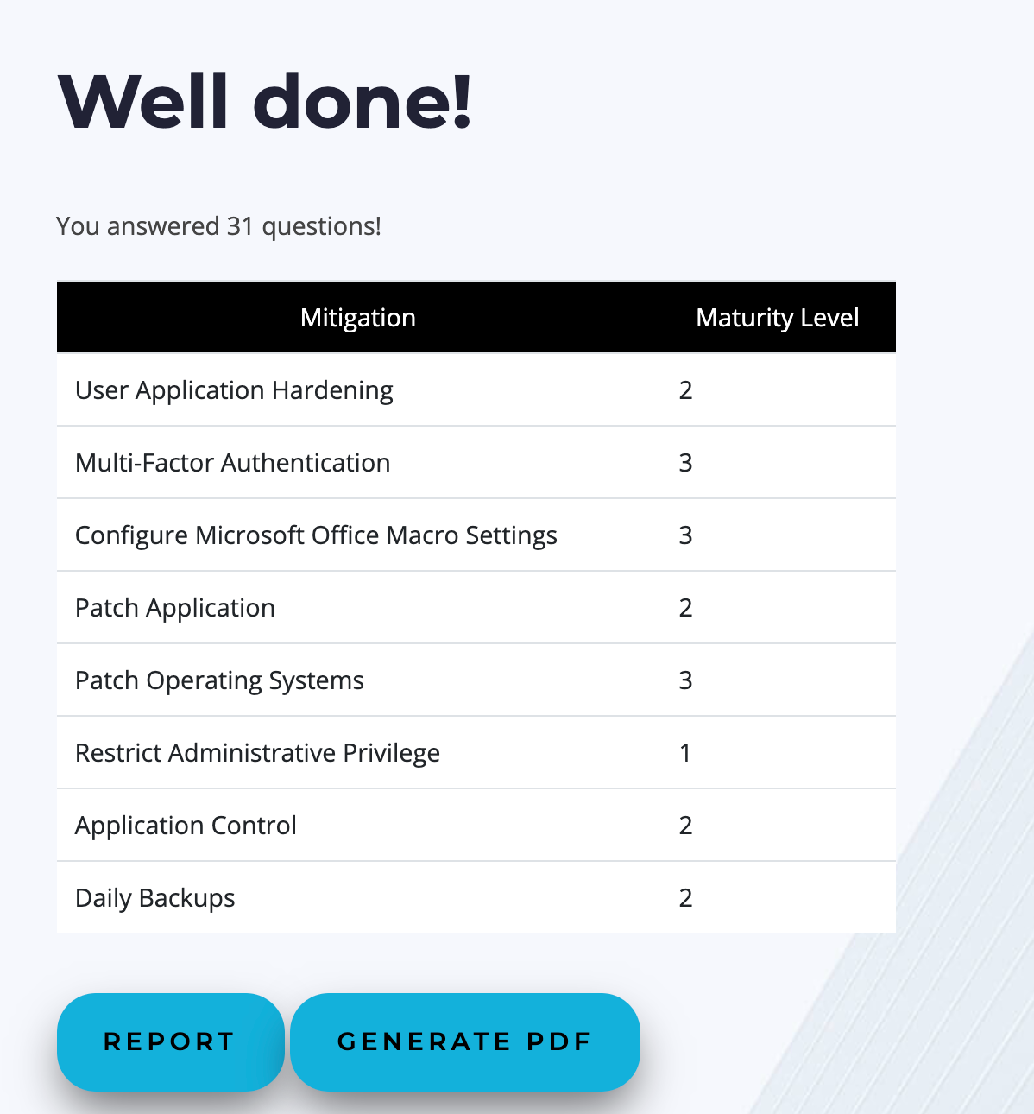

Once the User Clicks on the Report button the maturity level along with the recommendations is presented to the user as shown below:

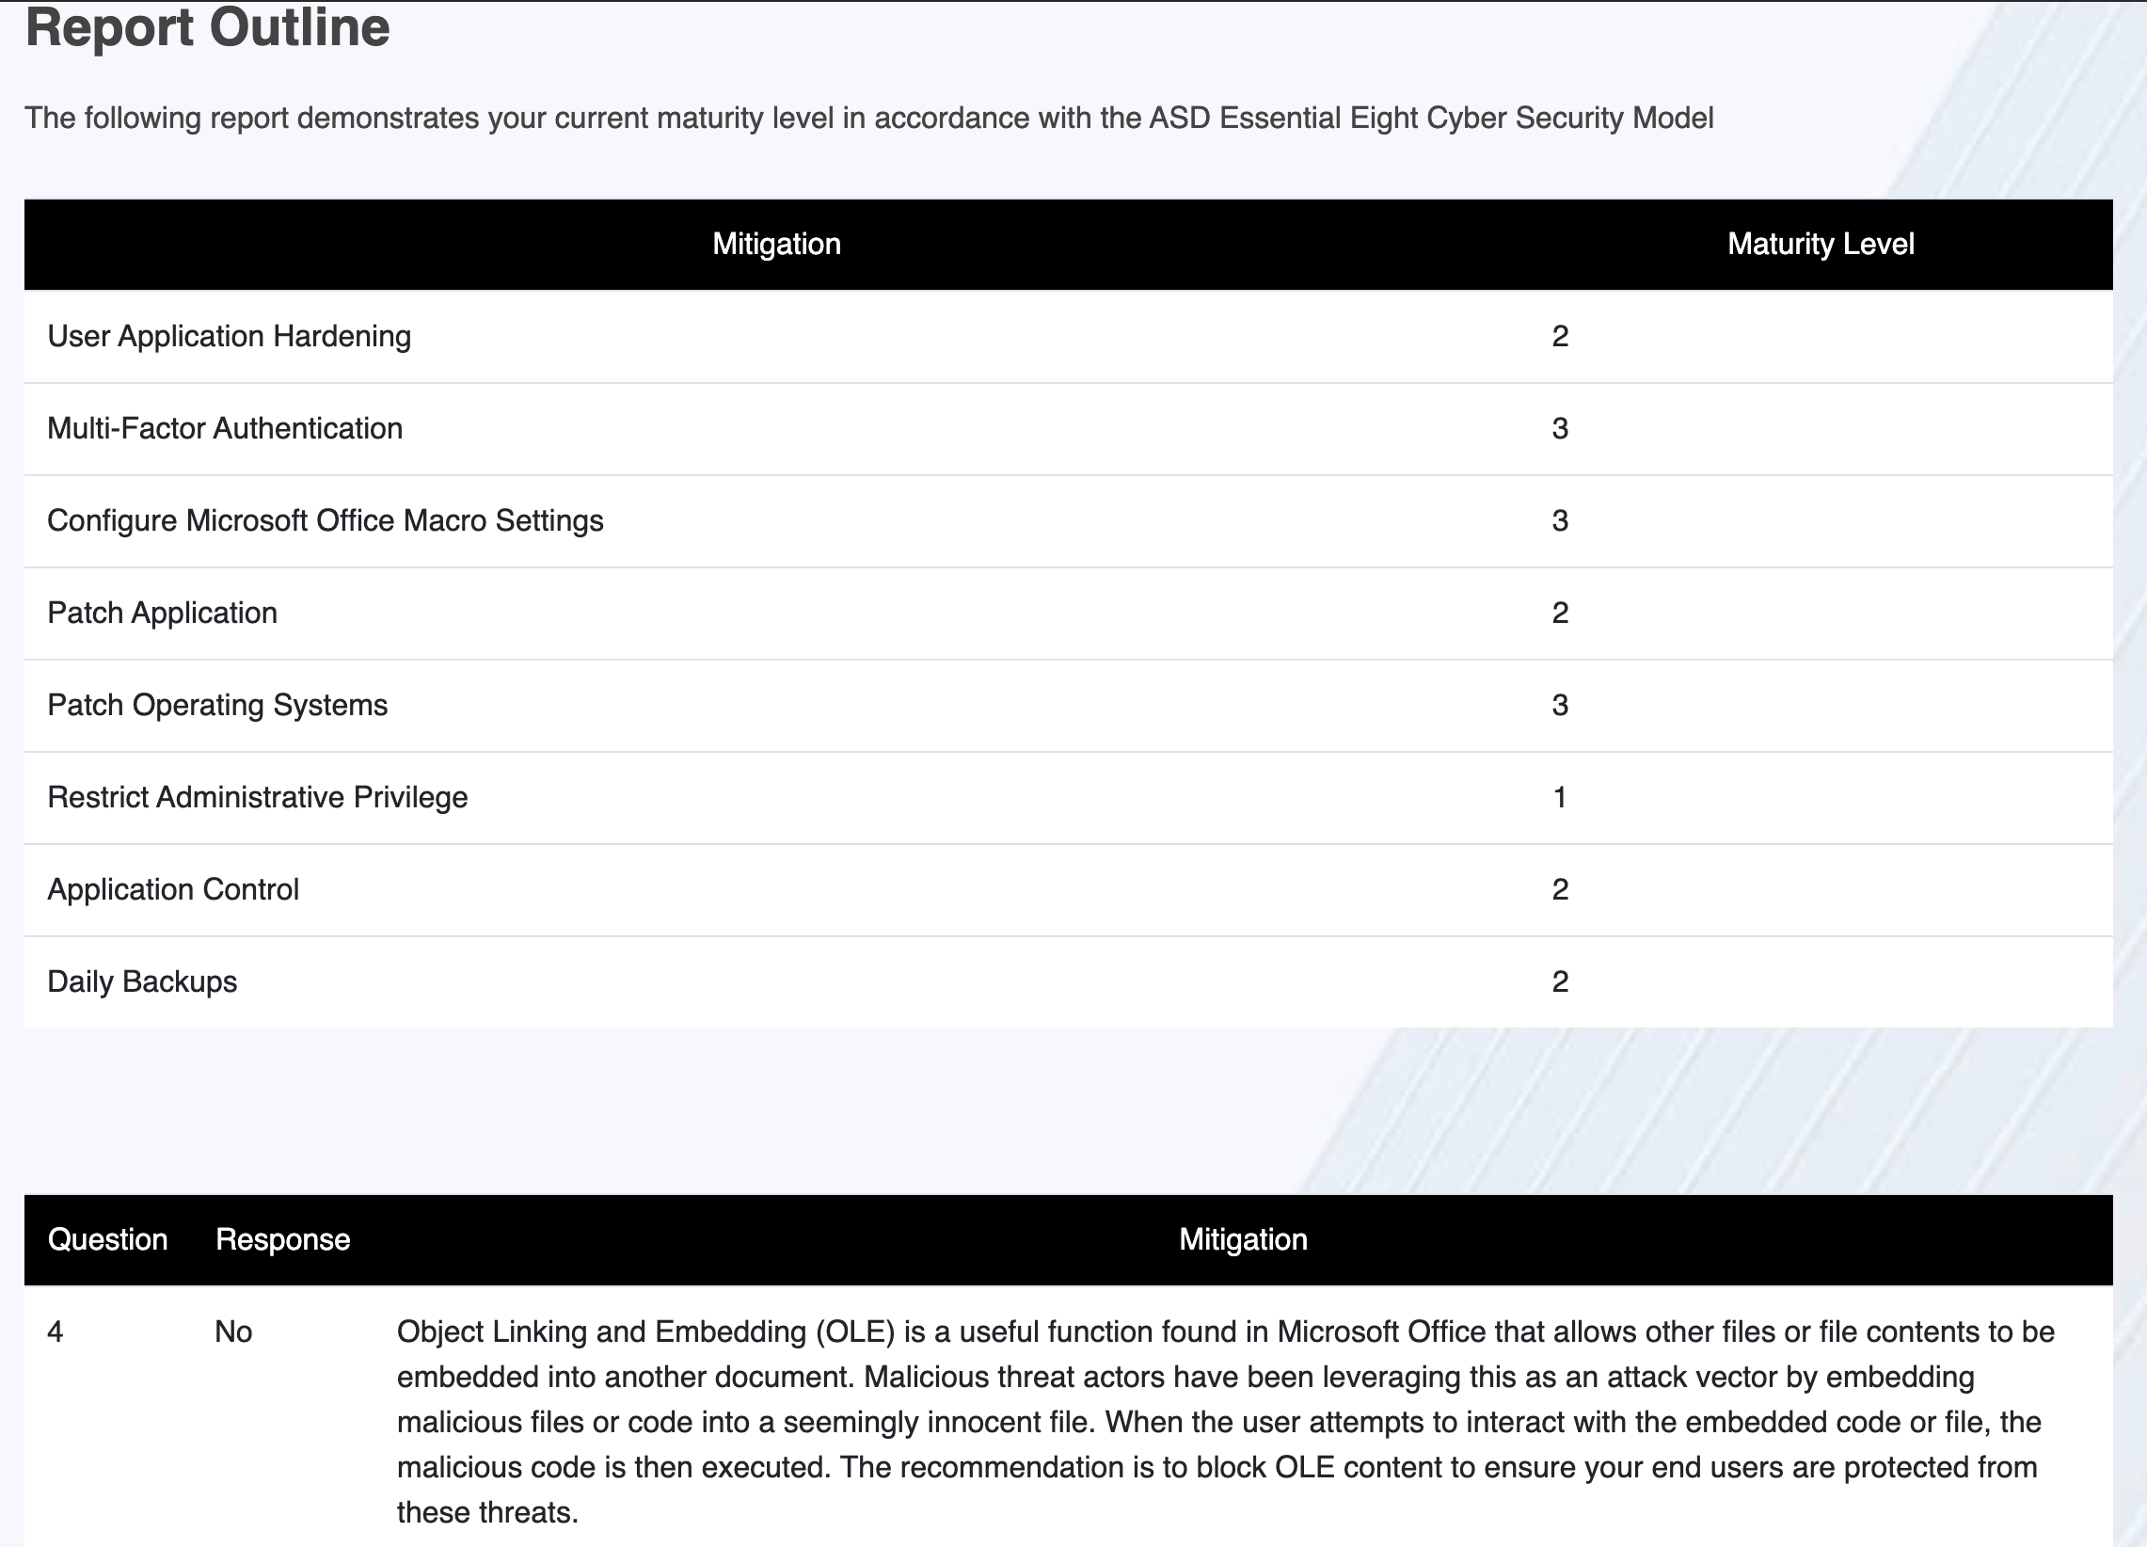

**NOTE: -** There is still a plan to improve the appearance of the report by making the results appear in graphical manner. This is yet to be implemented in the website.

# Details for PDF

An option for PDF is generated for the user to download their performance as a pdf document and store it for future reference. The PDF displays the Maturity level achieved by the user for the selected mitigation strategy as well as the recommendations for the undesired selections only. The screenshot below shows how the PDF will appear when seen or downloaded by the user.

